Design Software Information Sheet
SAP2000

11.0.8
Released 22 October 2007

www.csiberkeley.com

West Coast Liaison East Coast Liaison
Craig B. Goings John H. Thomsen

Updated: 22 January 2008

SOFTWARE DESCRIPTION | GETTING STARTED | LICENSE INFORMATION | KNOWN PROBLEMS | SOFTWARE TIPS

Software Description
Software: | SAP2000
SGH Licensed Version: | 8.3.3.1
Software Webpage | www.csiberkeley.com
SGH Software Support: | Yes
Type of Software: | 3D Nonlinear Structural Analysis
Keyword Description: | General purpose linear and nonlinear 3D analysis including linear static, nonlinear static push-over, dynamic response spectrum and linear or nonlinear acceleration input time history analysis (both modal and direct integration solution schemes).
Design Features: | Pre-processor allows for creation of model from general templates.  Aluminum Design Check  Cold formed Steel Design Check  Concrete Design Check  Steel Design Check  DXF model geometry output
Analysis Features: | Still includes text based input file  Heat analysis  Staged construction  FEMA 273 type criteria input for push-over analysis  Linear Elements: Beam, spring, membrane, plate, shell, nodal constraints and restraints, rigid diaphragms  Nonlinear Elements: Damper, beam flexural hinge, beam shear hinge, beam axial hinge, spring, gap, hook, Biaxial-plasticity base isolator, Friction pendulum base isolator
Interface: | Graphical pre and post processing.
License type: | Network license or optional hardware key.  SF and Boston both have network licenses.  Network license can be shared across SGH network.
Pros: | Fast model creation.  Intuitive pre and post processing  Efficient solution schemes.  Batch analysis mode.  Input and output results can be exported efficiently to Excel or Access for post processing.  Nice graphical interface output of results
Cons: | Both pre-processing post-processing requires license key.  Nonlinear solution schemes not robust enough for some element types and for models with high degrees of nonlinearity.  Direct integration nonlinear time history analysis is very slow and often does not converge.  Post processing of most results is done on the fly. This results in quick run times but often long post processing time

Back to Top of Page

Getting Started

West Coast Installation
Contents of installation CD have been copied to the network to:
I:\Software\SE\CSI\Sap 2000 V.8.3.2\Launch.exe
Run the setup program from this directory.
The setup program will ask what type of license key, select standalone.
The setup program will ask for the installation directory. Just accept the default.
The setup program should then install SAP2000.
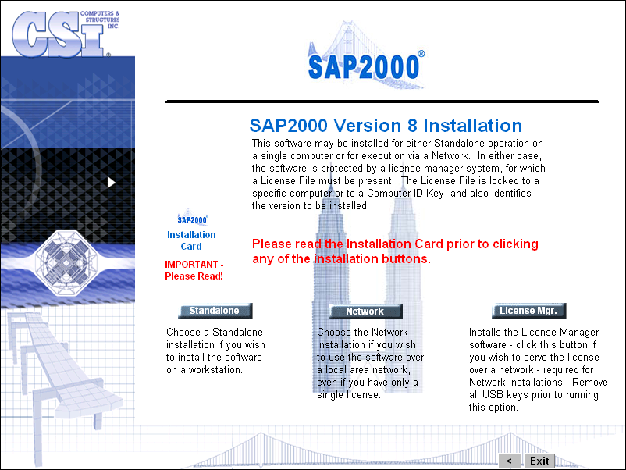
Patches are available for this version of the program. Unzip the following file into the directory that Sap2000 was installed:
I:\Software\SE\CSI\Patches\SAP2K8331\SAP20008331Update.ZIP
This will update the program to version 8.3.3.1

East Coast Installation
This section is being developed.

Back to Top of Page

License Information
The Boston office currently has one license and the San Francisco office currently has two licenses. The licenses in both offices are network type license in lieu of hardware keys (hardware keys are available from CSI in lieu of the network key). The Boston key is on IP address: 172.16.0.14 and the San Francisco key is on IP address: 172.17.0.15.
Either the Boston or San Francisco key can be accessed from any office or remote location with a VPN connection to the network. However, accessing keys that are not on the current local network will require modifying the adding or modifying a system environment variable. The variable can be accessed by performing the following operations:
- Right click on the “My Computer” desktop icon and select Properties
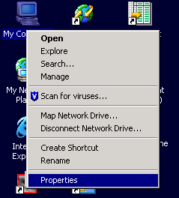
- Select the “Advanced” tab
- Click the “Environment Variables” button (middle or bottom of window)
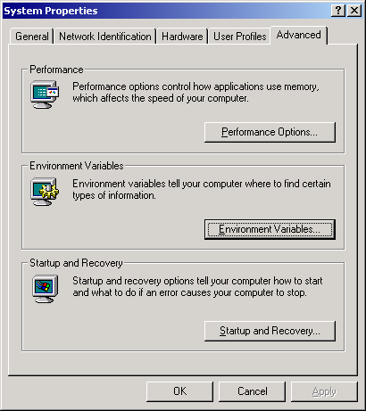
- Under “User Variables,” scroll down and select “lsforcehost” variable
- Click the Edit button
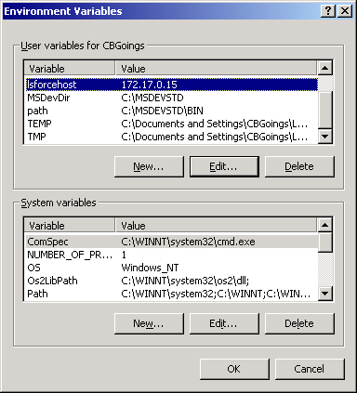
- Change Variable Value (IP Address) to:
- 172.17.0.15 for San Francisco
- 172.16.0.14 for Boston

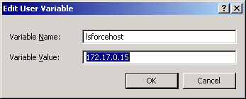
- Click OK to all dialog boxes.

Trouble shooting license key access
If a license key can not be obtained, try the following:
- Ensure that your installed version of SAP2000 is the current licensed version. Earlier versions of the software may not be able to use the current versions network key. CSI does not support pervious releases of its software and the license keys are not backwards compatible. SGH does not maintain a license agreement for previous versions of the software upon upgrade to the new version.
- Check to ensure that all the licenses are not being used using the program:
(SF Server) I:\Software\SE\_HardwareKeys\WlmAdmin.exe
- Double click on the Citrix link for the Boston key and the App2 link for the San Francisco key.
- Double click the SAPNL8 link.
- If the key is being used, the computer name that is currently using the key will be displayed as shown below:

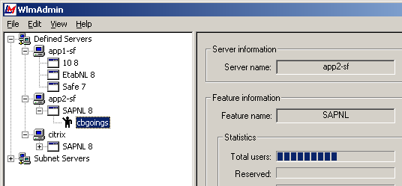

Back to Top of Page

Known Problems
Ending a running SAP2000 session using the ctrl-alt-del task manager feature may cause the analysis results files to be corrupted. If you have analysis results that took a long time to run, consider making a backup copy of the model’s entire directory so that you can recover the information should you have to end the SAP2000 task.

Back to Top of Page

Software Tips
Steps to setup a staged construction analysis:
- You must first create the model with all the elements and loads that are required to describe the analysis.
- Create groups of elements that will be added or deleted during the analysis. Be sure to include a group that represents the starting condition of the structure.
- Then create a nonlinear load case as shown in the following dialog:
- Edit the staged construction dialog to add the elements representing the starting condition of the structure.
- Then create additional load cases that start from the load case created in item 3 above as shown in the following dialog:
- Create additional load cases from 5 etc.

Back to Top of Page

/tmp/lo/0000.doc

